Player:

* Lvl. 32 Palkia, Lvl. 30 Venusaur, Lvl. 30 Infernape, Lvl. 30 Tyranitar, Lvl. 32 Lugia, Lvl. 28 Scizor

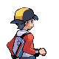

Gym Leader Lal:

* Lvl. 32 Pikachu, Lvl. 34 Raikou, Lvl. 32 Luxray

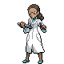

Gym Trainer Maddy:

* Lvl. 30 Ampharos, Lvl. 30 Jolteon



Gym Trainer Mahdin:

* Lvl. 30 Stunfisk, Lvl. 30 Manectric

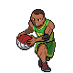

Gym Leader Arenas:

* Lvl. 36 Aggron, Lvl. 36 Excadrill, Lvl. 38 Cobalion

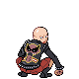

Gym Trainer Zawad:

* Lvl. 35 Skarmory, Lvl. 35 Metagross

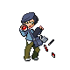

Gym Trainer Finn:

* Lvl. 34 Magneton, Lvl. 34 Empoleon

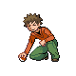

Gym Leader Guzzwell:

* Lvl. 36 Persian, Lvl. 36 Exploud, Lvl. 38 Regigigas

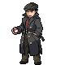

Gym Trainer Raeed:

* Lvl. 34 Snorlax, Lvl. 34 Slaking

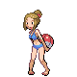

Gym Trainer Rakin:

* Lvl. 34 Dunsparce, Lvl. 34 Tauros

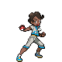

Gym Leader Hayward:

* Lvl. 38 Heracross, Lvl. 38 Lucario, Lvl. 40 Keldeo

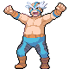

Gym Trainer Faijul:

* Lvl. 35 Toxicroak, Lvl. 35 Sawk



Gym Trainer Nicole:

* Lvl. 36 Machamp, Lvl. 36 Throh

